4th December 2023

Jack and the Beanstalk Pantomime

Dear Parent/Carers,

We have organised for the children from both schools to attend the pantomime ‘Jack and the Beanstalk’ on Wednesday 20th December 2023.

This will be a joint event for children at both Royd Nursery Infant School & Deepcar St John’s CE Junior School. The cost is £3.50, which for a professional production with full stage setting, lights and professional actors is an excellent price.

If you would like your child to attend please consent and pay via your Parentpay account before 13th December 2023.

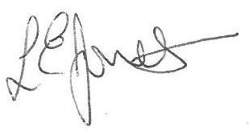
Yours sincerely,

Louise Jones
Executive Head

